Subject Characteristics (rounded to the nearest tenths)
Table Subject characteristics
Variable | n = 195
VM (cm) (CI) | 41.2 (40.7-41.8)
KF_B (cm) (CI) | 24.7 (24.4-25.1)
KF_A (cm) (CI) | 13 (12.6-13.3)
Circ_A (cm) (IQR) | 36.2 (34.6-38.5)
Leg (left - right) | 95-100
Side (lateral - medial) | 96-99
Gender (female - male) | 96-99

MP | Frequency
1 | 195
2 | 193
3 | 143
4 | 89
5 | 2

The square dimensions are rounded to the nearest hundredths.
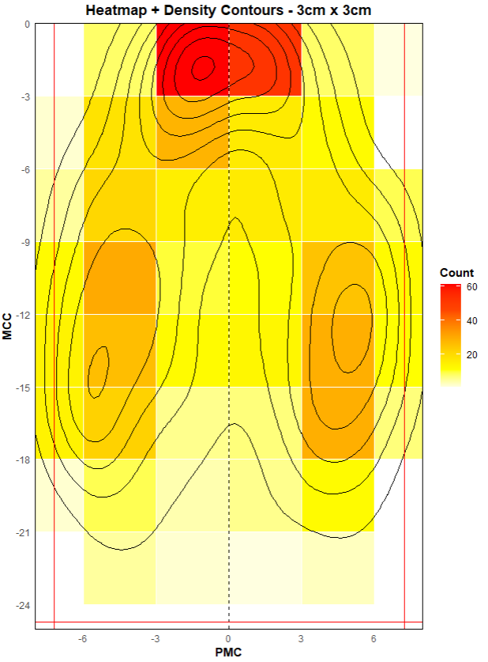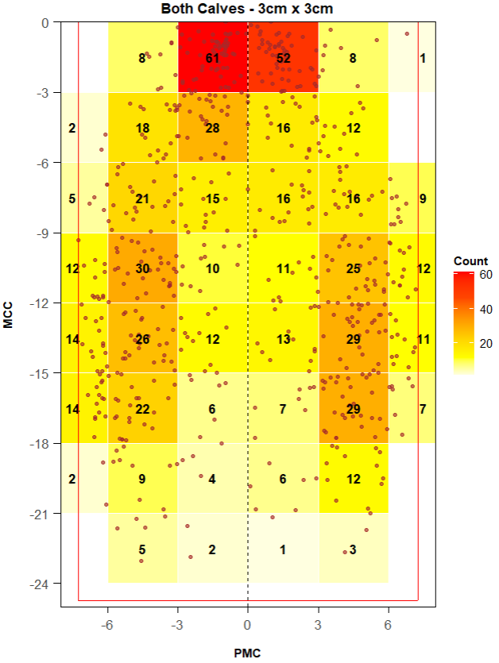
Heatmap + 3cm x 3xm squares
The partition into 3cm x 3cm squares is not particularly informative for this analysis. The point frequencies across aquares do not show sufficient marked differencesto crearly discriminate areas of genuinely higher concentration.
For instance, in the lower region, counts such as [2, 9, 4, 6, 12, 5, 2, 1, 3] are observed, which are relatively homogeneous among themselves. This lack of contrast also persists when compared with squares exhibing higher frequencies, such as [14, 6, 7, 7].
Consequently, discretizing the space using squares of this size attenuates the spatial differences that are evident in the continuous heatmap, where a clearer density gradient can be observed. This suggests that a 3cm grid is not well suited to capture meaningful spatial variations in the point distribution.

Hexagons with 3cm per side
Total squares | 6 x 8
Empty squares | 5
Total hexagons | x
Empty hexagons | x
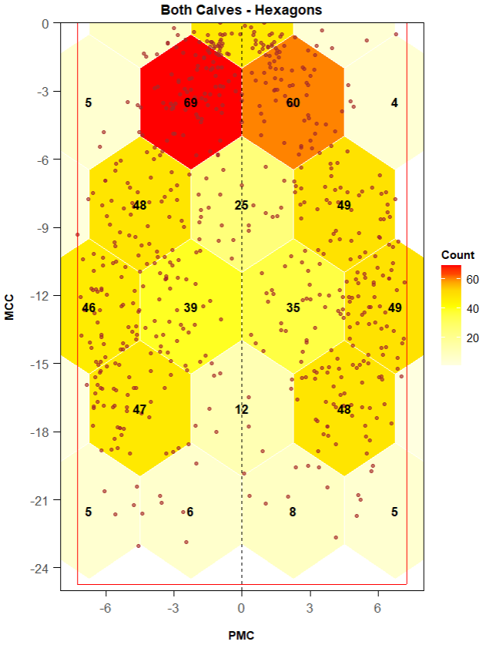

In contrast, the use of regular hexagons with a 3cm side length yields a substantially improved result. The hexagonal discretization reveals clear and meaningful differences in point counts between regions of high density and peripheral areas, providing stronger evidence of true spatial heterogeneity.
For example, in the lower region, the contrast between hexagons capturing [5, 6, 8, 5, 12] points and those capturing [47, 48] points are pronounced and consistent with the underlying spatial distribution. This marked separation was not evident under the square-based discretization.
Overall, the hexagonal grid preserves local density variations more effectively and aligns better with the continuous spatial patterns observed in the data, making it more appropriate and informative choice for this analysis.

Zone 1 Area

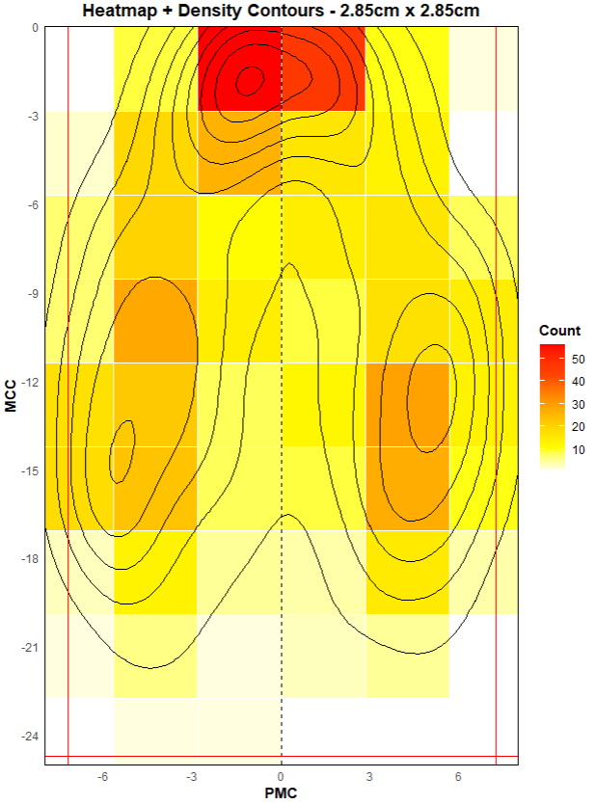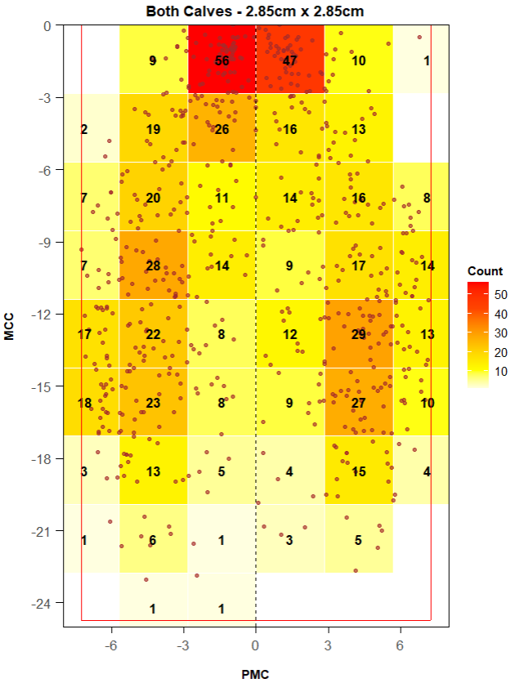

In this case, using squares with a side length of 2.85cm does not effectively capture underlying spatial structure. The limitation is essentially the same as in the previous scenario: the discretization still produces relatively homogeneous point counts across neighboring cells, which hinders a clear differentiation between high-density regions and peripheral areas.
As a result, meaningful spatial contrasts observed in the continuous heatmap are attenuated once the data area aggregated into square bins of this size, indicating that this resolution remains suboptimal for the analysis.

Cudrados Totales | 6 x 9
Cuadrados Vacíos | 7
Hexágonos Totales | x
Hexágonos Vacíos | x
Hexagons with 2.85cm per side
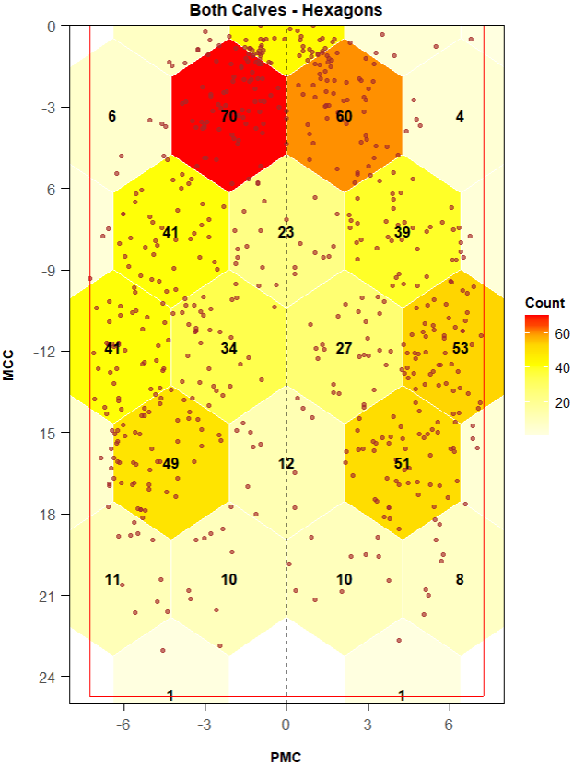

Compared to square-based discretization, the hexagonal approach is clearly superior. However, hexagons with a 3cm side length provide a more effective representation than those with 2.85cm side length. The larger hexagons reduce the total number of cells while enhancing contrast between high-density and low-density regions.
This coarser but more informative discretization amplifies differences across spatial zones, allowing dense areas to be more clearly distinguished from peripheral regions. As a result, the 3cm hexagonal grid offers a better balance between spatial resolution and interpretability for this analysis.

Zone 1 + Zone 2

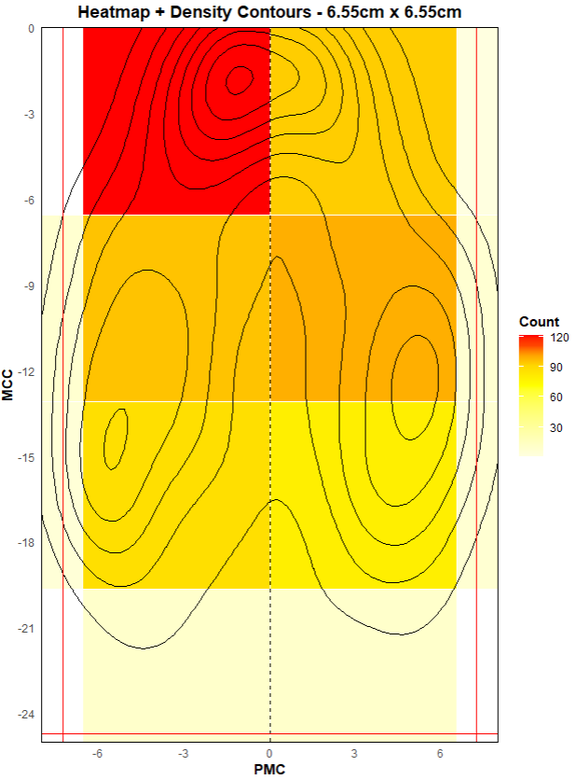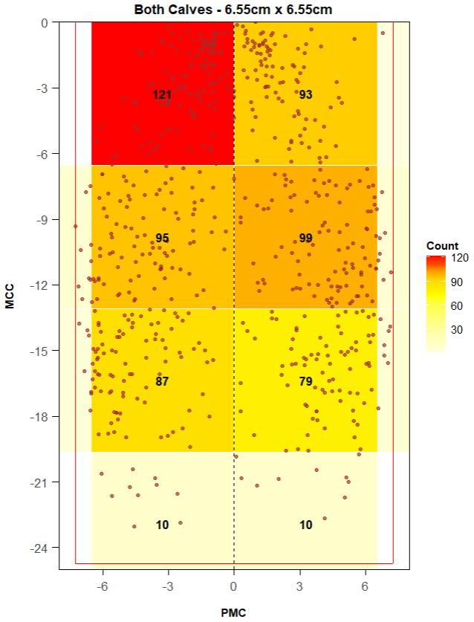
Cudrados Totales | 2 x 4
Cuadrados Vacíos | 0
Hexágonos Totales | x
Hexágonos Vacíos | x
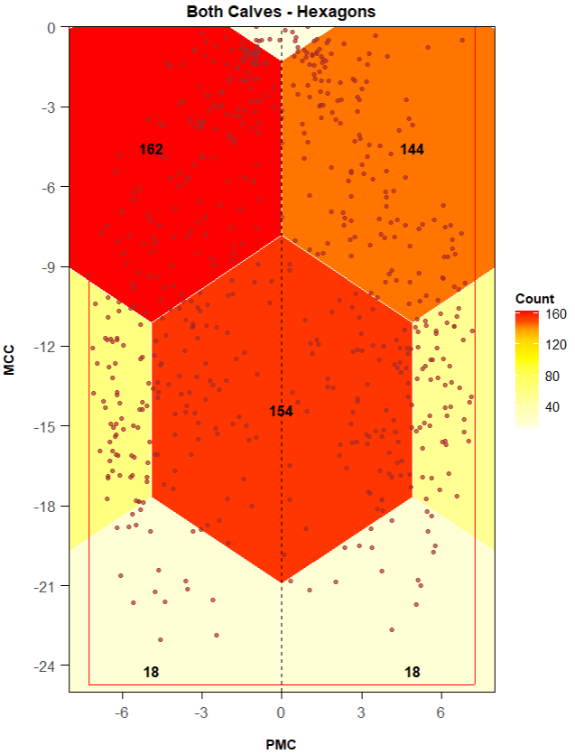

Sigma value = 1.2
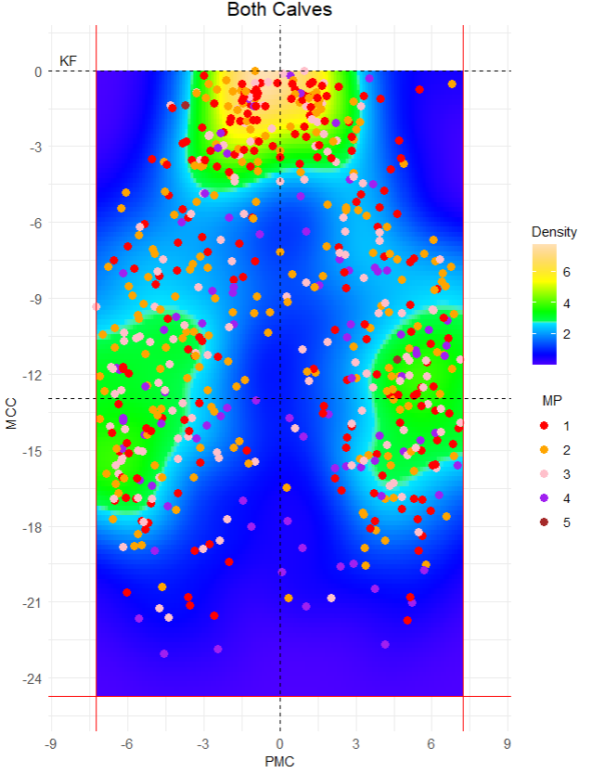
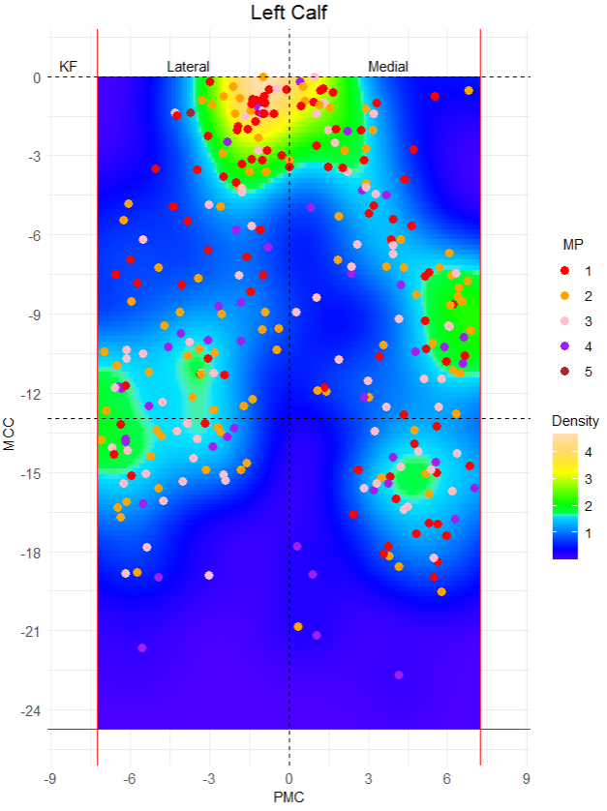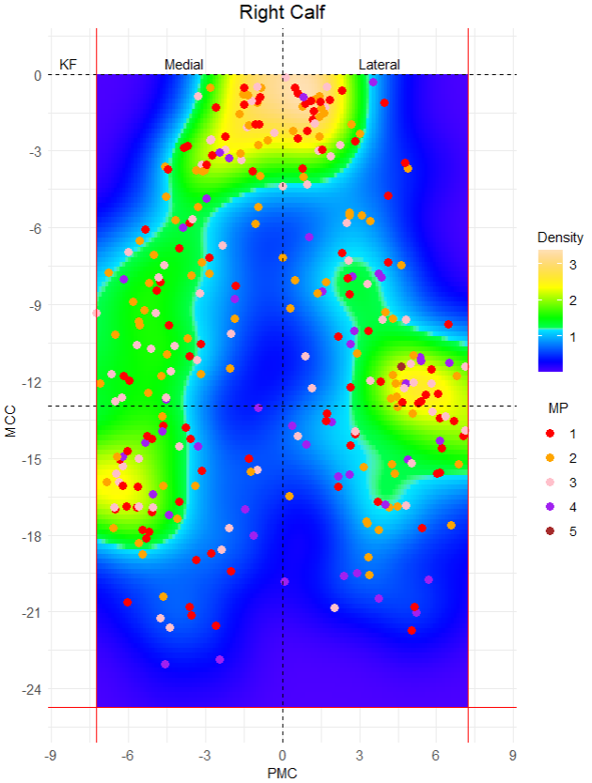

3D CALF
- Circ_A, Circ_B, Circ_KF
- Alturas: z(KF), z(B), z(A)
- Radios
- Sector: 30% x Circ_A, 45% x Circ_B, 25% x Circ_KF

